DAIRY FLAT SCHOOL AGRICULTURAL DAY 2020

LAMB

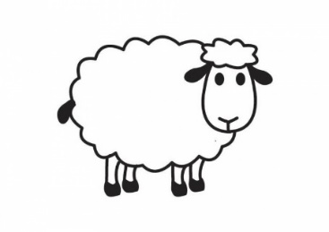

Information and Judging Criteria

The emphasis on Ag Day is on the child’s effort and care of their animal.

Lambs are to be hand reared, one animal per child.

The lamb is to be born after 1st July but before 15th September 2018.
You will need to work with your lamb regularly, so it is ready to be judged on Ag day. You will need to practice calling your lamb and leading it around the course, which will include a ramp, with a collar and lead (see below for course).
Your lamb will need to be used to being tied up and will need regular feeds of milk and a warm dry shelter to keep it healthy right up to Ag day. Lambs must not be weaned before Ag day
All lambs to be docked except for the breeds that do not require it.

On Ag Day you will need to bring your lamb to school with its collar and lead, a rope to tether it before/after judging, a drink in a suitable container. You will need to display your Ag Day number on your shirt.
JUDGING CRITERIA

1. Leading and Handling
- Most Obvious Pet (Calling)
- Rearing and Grooming COURSE LAYOUT for LEADING

3 5

4

2 6

- START 7.FINISH

1. Enter ring and Start (clockwise direction)
2. Lead lamb at a walk
3. Lead around outside of pole
4. Stop for a count of 3
5. Lead anti clockwise around pole
6. Lead up the ramp, pause, then jump off end
7. Lead past Finish and out of ring

1. LEADING

Lamb walks freely, not dragged

Lamb walks beside or slightly behind, on the right hand side of the child

Child sets the pace, lamb is able to start / stop when requested

Follow the set course

2. MOST OBVIOUS PET (CALLING)

The ring steward will hold the lamb

Child takes lead off and walks away – approx. 10metres

Child calls the lamb by name, if there is no response the ring steward will direct the lamb to the child

Child secures the lead back onto the lamb’s collar

3. REARING

Lambs must not be brushed or washed. Faces, ears, feet and rear ends may be cleaned. Washed lambs will be disqualified in the rearing section. Judges will be looking at the general condition of the lamb - size, health, free from foot rot and scours (You need to continue feeding your lamb regularly with milk only throughout the days leading up to Ag Day) Lambs must not be weaned before Ag day

The child should be able to answer questions relating to the lambs age, breed, how often, how much and what it is fed, what does the child do to keep the lamb healthy

THE JUDGES DECISION IS FINAL

The judging group may be made up of combined year levels.

If the child gets a 1st place in any category, they will need to be available to enter the Champion round of judging. Do not leave the Lamb area until all judging is completed and do not leave Ag Day until all the Champion rounds are completed.

South Kaipara Schools Group Day
This is a fun inter-school Ag Day held at Helensville show grounds on the first Friday of November. If you get a place ribbon for your Lamb you are eligible to enter Group Day. Please give child’s name, birth date and animal details to the school office before the end of Ag Day if you would like to enter. Parents/caregivers are required to attend this day with their child.

