DAIRY FLAT SCHOOL AGRICULTURAL DAY 2020
BLOCK CONSTRUCTION
This year’s theme is FARM MACHINERY
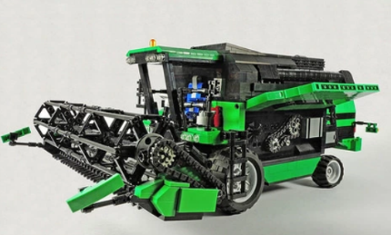
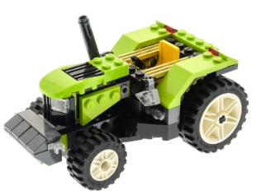
For this category you will need to make a MACHINE that works on a farm.
JUDGING CRITERIA:
1. ONLY LEGO, K’NEX or MECCANO BLOCKS CAN BE USED.
2. Make a machine that is easily recognisable eg: harvester, hay bailer, tractor, digger etc
3. Machine must have at least 1 moving part.
4. Judge will be looking for attention to detail.
5. Pre bought ‘Machines’ or model kits will not be judged.
6. Additions or backgrounds must also be created with Lego, K’nex or Meccano blocks.
7. Machine must fit on a solid A4 size platform, so that it can be moved if necessary.
8. Machine needs a label and a simple explanation of what the machine is.
9. All work is to be done at home by the child and brought to the
school hall on FRIDAY 16th OCTOBER between 8.15am-8.55
Models arriving after this time will not be judged.

You will need to display your Ag Day number on your exhibit
Judging criteria must be followed as stated on this sheet.

