DAIRY FLAT SCHOOL AGRICULTURAL DAY 2020
CHICKEN

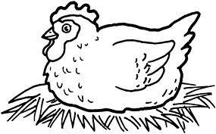

Information and Judging Criteria
Only the Brown Shaver chicks purchased through Dairy Flat School will be eligible for judging on Ag Day. It is recommended you purchase 2 or more chicks to ensure you have 1 to bring to Ag Day.

Along with raising the chick, each child entering this category is required to present a written diary of the chick’s growth, development and care.
Make sure you put your Ag Day number on the diary, not your name.

Diaries must be handed into the school office before 9am Tuesday 14th October for judging. Diaries handed in after this time will not be judged.

Attach your Ag Day number to the cage so it is clearly visible for judging. The child must be present, standing alongside their chicken during judging as the judge will ask the child questions about their chicken.

No parents/caregivers are allowed into the judging area during judging.
JUDGING CRITERIA

DIARY
Judges will be looking for creative design work with particular emphasis on how much information and effort (age appropriate) has been put into the diary by the child.
Diaries must include pictures, photos and/or drawings. Ideas could include information about size, weight, housing, food.

CHICKEN
Judges will be looking at the general condition and health of the chicken along with understanding the child’s knowledge of their chicken.

THE JUDGES DECISION IS FINAL

