**Information about Dairy Flat School that you might find helpful.**



**'Striving For Excellence While Caring For Others'**

Mission Statement

To provide the best possible learning experiences and environment, assisting children to gain the knowledge, skills, attitudes and values necessary to attain their potential and become responsible, confident people.

At Dairy Flat School we aim to:

* Provide a secure and caring environment for learning,
* Support students to become lifelong learners and productive citizens,
* Be a school which values the partnerships between staff, students, Board of Trustees, parents and the community, where all play an equal role in the success of every child.

Dairy Flat School has a long and proud tradition. The school was established in 1878, and from old accounts of the district, Dairy Flat had a predecessor, Pukeatua School, which had a roll of twenty. The school has certainly progressed from its early beginning and now proudly offers excellent learning and teaching. We are responsive to the community and needs of the children.

Our logo depicts the original school which was sited on Jeffs Road.

Several factors combine to make Dairy Flat a wonderful learning environment:

* teachers committed to providing the very best education for our students,
* students who care for each other,
* staff who strive for success,
* spacious grounds with excellent facilities,
* a rural haven close to Auckland, where life values are treasured,
* and strong support from our Dairy Flat community.

Welcome to Dairy Flat. This is your school and we welcome your input to the direction of your children’s learning. Please don’t hesitate to phone me or call in. Parent contact and feedback is important and I look forward to meeting you and getting to know you.

Debbie Marshall

Principal

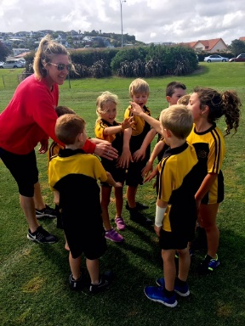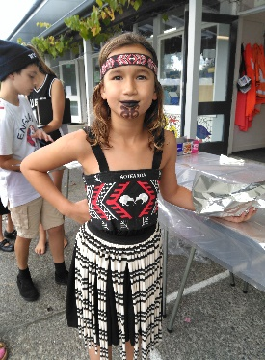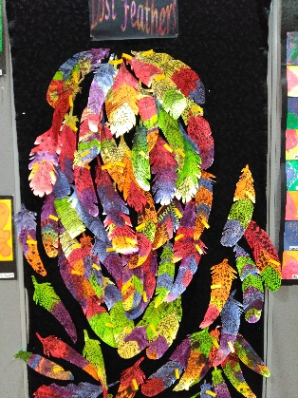

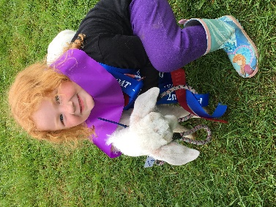

**STAFF LIST 2019**

**Principal** Mrs Debbie Marshall

**Assistant Principal** Mrs Susan Thompson

**SENCO** (Special Needs) Mrs Julie Atkinson

**LZ1 (Year 5/6)** Mrs Susan Thompson, Mrs Penny Jefferson, Mrs Jenny Forlong, Mr Shayne Grice

**LZ2 (Year 3/4/5**) Ms Courtney Ryder, Mrs Hayley Campbell, Ms Clarisse Harman

**LZ3 (Year 2/3)** Mrs Fran Earwaker, Mrs Robyn Mowat, Ms Marama Waaka

**LZ4 (Year 0/1)** Mrs Lyndy Committie, Mrs Jody Costello, Mrs Rhonda Blair, Miss Lauren Vaughan

**Office** Mrs Suzanne Hayward

Mrs Paula Lucas

**Library/Support Staff** Mrs Karen Moss

**Support Staff** Mrs Debbie Anthony

Mr Dafydd Evans

Mrs Gina Nel

Mrs Nicole Gardener

**Property** Mr Jim Meacock

**Sport co-ordinator**  Mrs Lyndy Committie/ Mrs Courtney Ryder/Mrs Fran Earwaker

**Music Tutors at our School**

**Choir** Mrs Fran Earwaker;

**Piano Tutor** Music Education Centre, Raewyn Thomas

**Drum and Guitar Tutor** Mr Nick Morgan

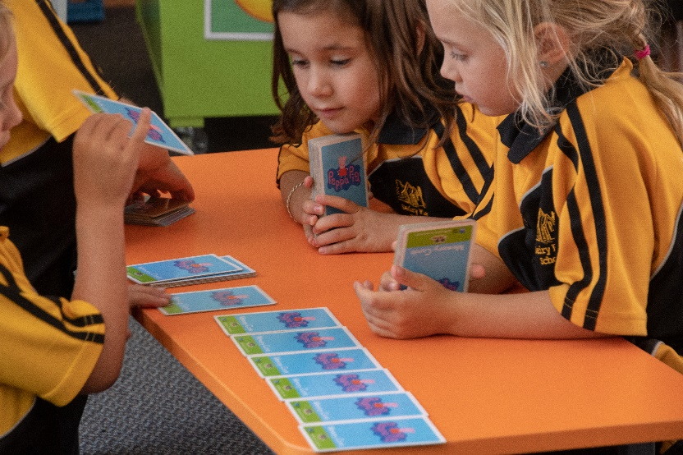

**TERMS AND HOLIDAY DATES FOR 2019**

**Term 1              Monday 4 Feb – Friday 12 April  
                          Waitangi Day – 6 Feb  
  
Term 2              Monday 29 April – Friday 5 July  
                          Queen’s Birthday – 3 June  
  
Term 3              Monday 22 July – Friday 27 Sept  
  
Term 4              Monday 14 Oct – Wednesday 18 Dec  
                          Agriculture Day – 19 Oct  
                          Labour Day – 28 Oct**

**SCHOOL TIME TABLE**

  8.50am Children to go to their class to hang up their bag

8.55 Start of the school day – classroom roll

9.00 Learning Time

(at approximately 10am brain food break for 5 minutes)

11.00 Morning Tea

11.30 Learning Time

1.00pm Lunch

1.45 Learning Time

2.55 End of school day

 Students may settle into class from 8.30 am and may not be at school before 8am. This is a safety issue. Staff are onsite from 8:30am onwards and children arriving before this cannot be supervised. aPlus Out of School Limited provides before school care in the school hall from 7am for those children who need to be dropped off earlier (aPlus run before and after school care in our school hall, Monday to Friday. Phone 0800 423 400 or 09 443 5386 or visit [www.aplus.kiwi.nz](http://www.aplus.kiwi.nz) or email [admin@aplus.kiwi.nz](mailto:admin@aplus.kiwi.nz) for further details).

Please ensure that your child is at school by 8.45am. Your child needs time to greet friends, hang up his/her bag and settle in to class before the bell goes (1st bell goes at 8.50am – all students must head to class for the morning roll to be taken at the 2nd bell at 8.55am).

Children who come late to school are a disruption to the whole class and often miss out on information vital to the day lesson.

If for some reason your child is late to school, please ensure you sign the late book in the school office. Rolls are marked at the start of the school day and your child will be marked absent if not in class. For safety reasons phone calls are made to the homes of children who are marked absent (this may also include students arriving late, hence the importance of signing the late book if arriving after the school bell for the start of day).

Please advise the school by 9am if your child is going to be absent – you can complete the absence form through our website, or, phone the school and leave a message, or, email [office@dairyflat.school.nz](mailto:office@dairyflat.school.nz)

**BOARD OF TRUSTEES 2019**

Dairy Flat School is ably governed by the Board of Trustees. The BOT is keen to see Dairy Flat School continue to develop a quality education for all students. We are eager to receive input from our community and look forward to promoting positive relationships. You are welcome to attend Board of Trustee meetings. These are public meetings, though you do need to request speaking rights prior to the meeting if you wish to speak. Any issues need to be put on the agenda 5 days prior to a meeting. We warmly welcome parents and community members to our meetings which are advertised in the newsletter and on our website.

Members:

Stuart Woolford (Chairperson);

Keith Bremner;

Paula Lucas;

Sarah Lloyd;

Dave Marks

Fran Earwaker (Staff representative)

Debbie Marshall (Principal)

The Board sets and reviews policies for the school, and thus provides direction to the management and growth of learning in the school. This Board has in place a strategic plan, and welcomes input for future direction. The strategic plan is set annually and specifically states the goals for the current year and beyond.

Please note that there are elections this year to elect a new Board of Trustees for 2019 – 2022.

[NZPTA](http://www.nzpta.org.nz/)

**PARENT TEACHERS’ ASSOCIATION**

Key positions on the PTA (parent teachers’ association) are elected annually. All parents and caregivers are members of the PTA and are very welcome to attend all meetings. This group has a very important role within the school. They fundraise vigorously, which is a huge task. They also organise school discos, co-ordinate school lunches and a subcommittee organises Agriculture Day. **Their email is dairyflatschoolpta@gmail.com**



**ENROLMENT**

**Dairy Flat School** has worked with the Ministry of Education and implementing an enrolment zone as of 1st January 2017.

To enrol your child you need to make an appointment and complete the enrolment form. We would like to give you the opportunity to look around the school and ask any questions you may have.

**PRE-ENROLMENTS** (new entrants)

We invite you to visit the school prior to your child’s enrolment. Your child will be asked to spend approximately 6 morning sessions in the new entrant room as part of the transition process (these are currently held on Friday mornings, 8:55-11am).

**Birth Certificates:** a copy of your child’s birth certificate is legally required on admission. You will also be supplied with an enrolment form to be completed prior to your child commencing school. You also need to supply a record of your child’s immunisation.

Please note that your child is unable to commence school till they have reached their fifth birthday.

**Immunisation Certificates:** a copy is legally required for all new entrant enrolments.

**Passports:** a copy of your child’s passport or relevant visa information is required if your child is not a New Zealand citizen. In some cases payment as a foreign fee student may apply.

Please also provide the school with any other relevant information/documents (e.g. custody arrangements; special need requirements; health or any other relevant information).

**FOREIGN STUDENTS**

We welcome students from other countries.

To enrol, student and parent need to make an appointment with our principal.

Please note that students must live with a parent.

**See our principal to discuss further or ask for an International Student prospectus.**



**FEES and Donation**

**BUYING STATIONERY**

Stationery lists are available from the office, on the school website and are provided to parents at the end of the previous year with the students reports. Purchase from OfficeMax – they also provide the school with a contribution, relative to purchases made. Please note that the school does not sell stationery (except home reader book, book bag, handwriting book and maths basic facts book).

**SCHOOL RECORDS**

Up to date contact information is vital should an emergency occur. Any changes in phone numbers, addresses, family circumstances, health problems, custody, or other important information should be recorded to the school office as soon as possible.

**SCHOOL UNIFORM**

It is compulsory for all students to wear the complete school uniform. The uniform is available from Argyle. You can purchase online. The school does not sell any uniform items but we do have samples at the office to try on.

**CLOTHING**

1.  Uniform must be worn at all times (sunhats term 1 and 4). Please follow the link to order <https://www.argyleonline.co.nz/shop/rodney/dairy-flat-school> or phone 0800 11 00 59. Girls can wear the skorts or shorts, and boys wear the shorts. Uniform is also available at Positive Image, Unit B, 16 Silverdale St, Auckland.

2.  Swimming lessons are provided on most summer days, and all children are expected to participate – please provide named togs, towel and goggles.

3.  Clothes need to be named. We often have an excessive amount of lost clothing. This is kept in the ‘Lost Property’ area and disposed of at the end of the term.

4. Sunglasses are an optional uniform item – these are for sale at the school office – only the school supplied blue sunglasses are allowed to be worn (no other brand, style of any other sunglasses are allowed, unless prescription sunglasses).

5.  Jewellery creates a safety hazard; rings and earrings should **not** be worn.

6.  The wearing of sunhats in Term 1 and 4 is compulsory. The school also has a large shade area for children to play in away from the heat of the midday sun. Dairy Flat sunhats can be purchased from Uniformity.

7.  Make-up and nail polish are not allowed.

8. Long hair must be tied back.

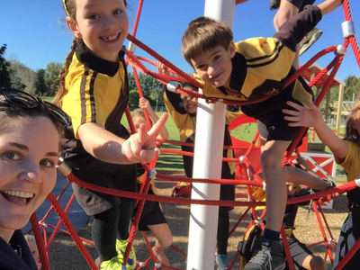

**BUS TRANSPORT**

**Please keep the school bus bay clear at all times.**

The Ministry of Education provides free bus transport on defined bus routes for children aged 5—9 years living at least 3.2 kms from school and for children aged 10 plus years living at least 4.8 kms from school.

Please meet your child off the bus each day. It is possible that your child may have to walk up to 1.6 kms to the nearest school bus stop. Please check your eligibility at the school office. Responsible older pupils are asked to be bus wardens. Please complete the bus permission form that is in the enrolment pack.

If you have a change to the end of day bus, please contact the office before 2.30pm.

**Unacceptable behaviour on buses will not be tolerated and pupils will lose the privilege of using the buses if behaviour is inappropriate.**

**DROP OFF/PICKING CHILDREN UP FROM SCHOOL**

The Kiss ‘n’ Drop Zone is an area outside the office where children can be dropped off in the morning. **Parents are asked not to leave their vehicle in the Kiss ‘n’ Drop Zone area, and are also asked to please keep the bus area free AT ALL TIMES.**

**Walking to school on the Main Road is not permitted unless supervised by an adult.**

Please note children do not have access to their classroom until 8.30am.

When picking your child up from school it is essential that you park your vehicle in the school car park, and collect your child from the hall deck. Your child should be in this area immediately after school if they are not in the bus line (outside LZ1) or at aPlus after school care or a school activity. Children are not to be collected from the car park area. We ask that parents do not wait for their child outside their class as the noise may be distracting for end of day notices and class activities – we appreciate your understanding with this. If you have any changes to end of day bus or pickups, please advise the school.

**WHEN YOUR CHILD IS SICK OR ABSENT**

 Please phone, email or complete the absence form through our website by 9.00am to inform us when your child is away. This establishes clearly where your child is. If we haven’t heard from you, we will ring you to find out the reason for the absence. Please save our busy office staff from ringing, by ringing first. We do have an answer phone on our 2 school lines or you can email [office@dairyflat.school.nz](mailto:office@dairyflat.school.nz) or complete the absent section from our school website.

Truancy services will become involved if a history of continuous absence without reason is recorded – please contact the school before this becomes an issue.

Please ensure the school has correct contact information in case of illness or emergency. If your child is unwell during the school day, your child will be attended to in the sick bay and if required, you will be contacted and may be asked to collect your child from school.

**HOMEWORK**

 The school believes that homework assists in developing independent work habits and consolidates class work.

A copy of the school’s homework policy is available from the school office. Please help us by encouraging your child to complete the work which has been set.

Junior children take home a reading book each day.

Children in the middle school take home a reading book, revise work on basic facts, and are asked to do simple research such as a current event.

Senior students may be asked to read, revise maths, locate data and complete assignments.

**Homework Guidelines:**

Year 1 to 2 10 minutes 4 nights per week

Year 3 to 6 20 minutes 4 nights per week

Year 7 to 8 30 minutes 4 nights per week

**INFORMATION COMMUNICATION TECHNOLOGY**

Dairy Flat School has made a commitment to moving ahead with the changes and development in technology. The school is fully networked. Each classroom is connected to the internet and email. Most classrooms are equipped with interactive whiteboards and sound systems.

Students have an opportunity to use computers, digital cameras, video, scanners and printers.

Students also have access to computers, robotics and DVD/podcast production equipment.

Students may also ‘bring your own device’ to school if authorised by their parent and teacher (a BYOD permission form must be completed and returned to the teacher).

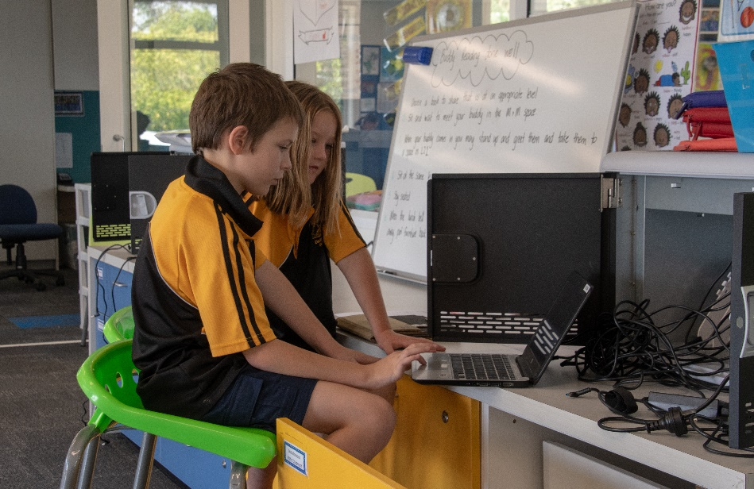

**BEHAVIOUR**

We have introduced a proactive behaviour management programme that teaches the children the values and behaviour we expect to see in our school.

|  |  |  |
| --- | --- | --- |
| Strive For Excellence – Care For All | | |
| **Respect - Manaaki** | **Responsibility** | **Resilience** |
| ***Respect ourselves, others, and our environment*** | ***Make the right choices,  be responsible for my actions*** | ***Believe in yourself Stay positive Keep trying*** |

We invite our parent community to join us and support this learning of behaviours. Classroom blogs and newsletters will regularly feature information about our expectations.

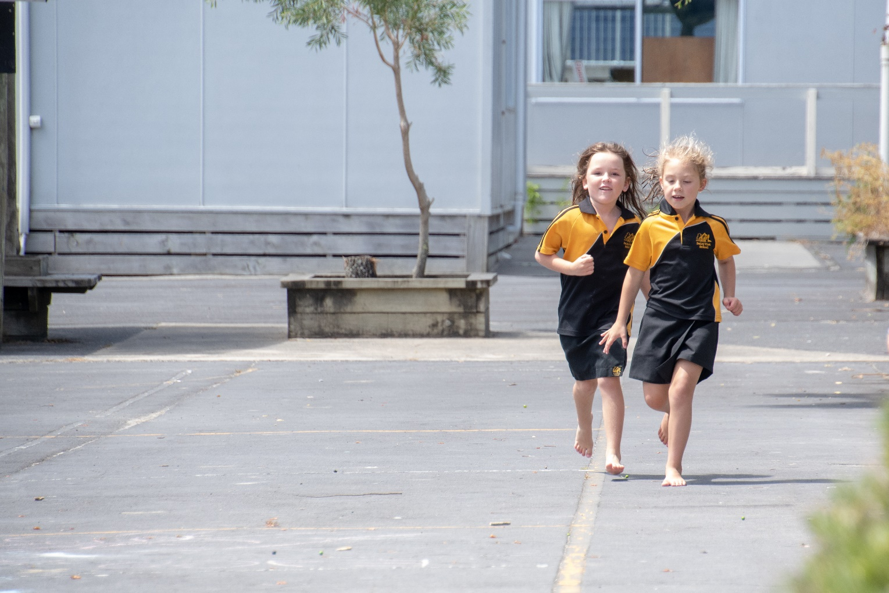



**Reporting to Parents**

There are several occasions when teachers report student progress to parents. These are:

* Meet the Teacher
* Mid Year Written Report
* Mid Year – Sharing Learning Conferences
* End of Year Written Report

This is to be reviewed this year and we will be asking our parent community their views.

**COMMUNICATIONS**

The school newsletter is emailed to parents and is available on the website. It is published every Thursday. The newsletter contains general news from the school, forthcoming events and other information. The school website is www.dairyflat.school.nz and contains information on school events, stationery, policies and other important school information. Newsflash items may be emailed out as reminders to coming events, important details, etc.

**LIBRARY**

All children are encouraged to use the library, and all classes have regular library periods in which children may choose and withdraw books.

Please assist your child to care for books on loan and to return them by the due date. Book bags are essential to keep library books in good condition.

**BOOK CLUB**

A Book Club is operated at the school through Scholastic Books. This provides an opportunity for parents to purchase reasonably priced books for their children about six to 8 times each year. In return, the library receives certain points from each school order with Scholastic to add book resources to the school library.

**LOST PROPERTY**

It is essential that each item of your child’s clothing and property is clearly named. Lost property can be found in the lost property box outside the staffroom. At the end of each term all found articles are displayed for claiming. Any unclaimed items remaining are placed in a charity clothing bin.

**ASSEMBLIES**

Usually on two Fridays a month at 9am, the school will gather to celebrate the events, enjoy songs and receive notices, certificates, have visiting guests, etc. Parents/Caregivers and friends of the school are invited to attend when appropriate (check the newsletter or website for assembly days and times as these do change). Each room will be responsible for preparing and running one assembly each term.

General format of assemblies:

1. Class sharing items

2. Teacher’s certificates

3. Principal

4. Values Awards

**AGRICULTURE DAY**

“Ag Day” is an institution, a local celebration of the unique and rural nature of Dairy Flat School. The whole community enjoys the efforts our children have made in rearing and grooming lambs, calves or goats, and in producing handcrafts and art works. This special day is shared by newcomers to the district and old identities alike.

“Ag Day” is held in mid-October (usually the first Saturday of term 4) and is the culmination of months of planning and work by the Agriculture Day Committee, the staff and the children. “Ag Day” takes place on a Saturday and is considered a school day.

We recommend that you encourage your child to learn to hand-rear and be responsible for a lamb, a calf, chicken or a goat. They can then enter their pets on the day and demonstrate their commitment to their pet.

Details are available from the school, and explanatory newsletters are sent home closer to the event.

This is the PTA’s major fundraising event of the year and your support is requested. Each class have an area of responsibility on the day and parent/caregivers will be contacted prior to Ag Day. This is not a big commitment when shared between all families.

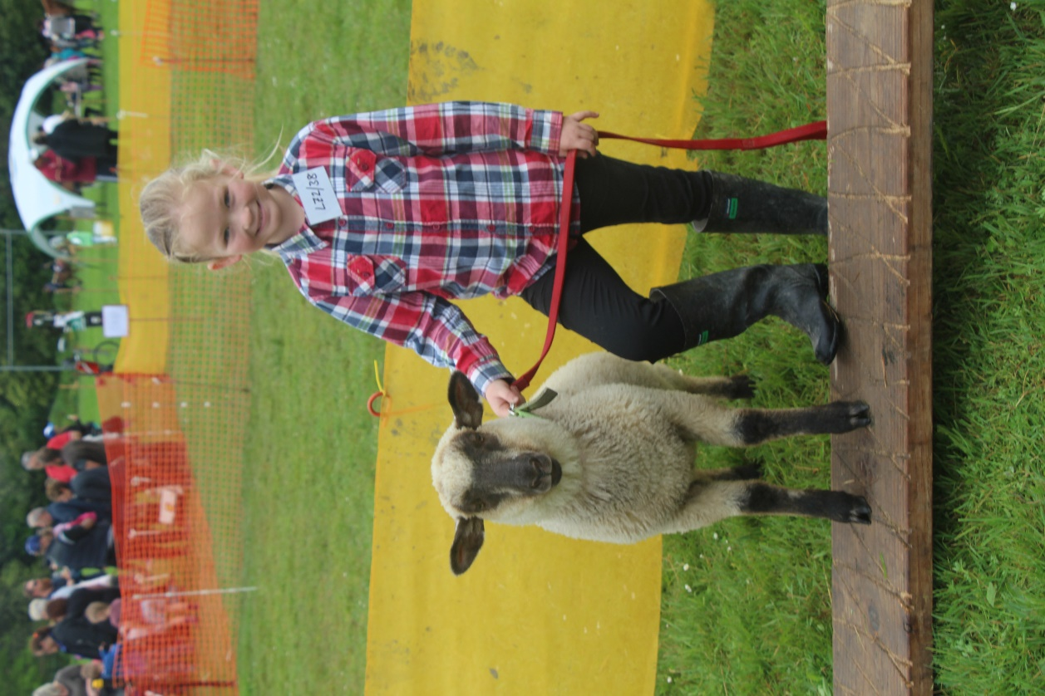

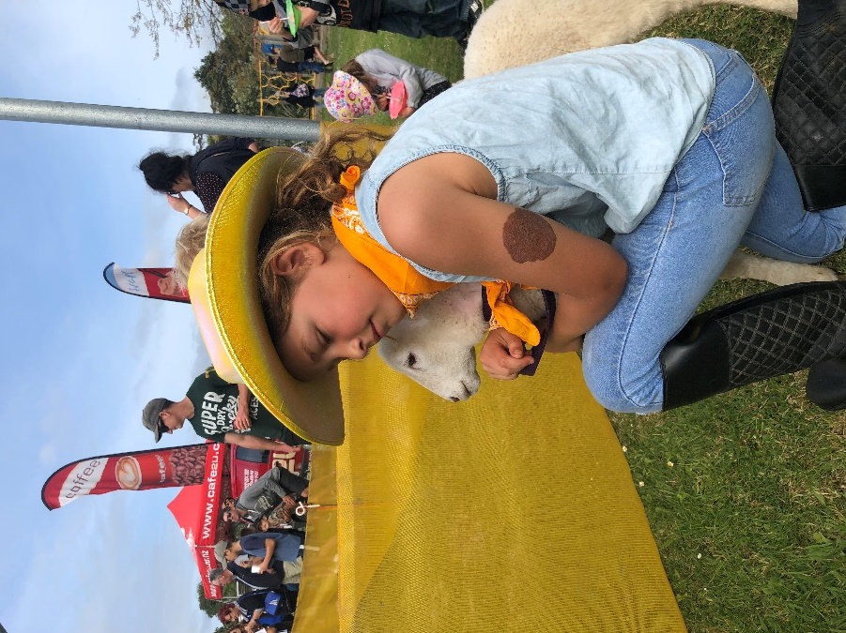

**SCHOOL PICNIC**

The school picnic is held in February each year. This has been a Dairy Flat tradition since 1878. This is a great day where students, teachers, parents, caregivers, and family friends all come together in a relaxed, fun atmosphere.

There are activities and events throughout the day where the students take part in their house groups – on enrolment, each child/family are placed in 1 of four house groups (their teacher will advise them which group they are in – events through the year students are asked to wear a t/shirt of their house colour).

**SAUSAGE SIZZLE**

Sausage Sizzles are run by each team on Wednesday lunchtimes for $1.50. Children are asked to take their money to their class first thing in the morning. The money raised by each team is used for class activities, trips and/or resources.

**SPORTS**

Sports teams are organised at school for after school and weekend games.

We are able to offer Touch, Netball, Hockey, Rippa, Basketball and Soccer. You will be advised of any upcoming events/registration via the Newsletter and of any new sport activities.

**HOW PARENT/CAREGIVERS CAN HELP**

• Get involved!

• Work as a parent help when your child is in the junior area,

• Provide a suitable place at home where homework can be done,

• Ensure your child has breakfast **and** lunch provided,

• Take an interest in what your child is doing,

• Read our regular newsletters and notices,

• Make sure your child has the correct gear/equipment,

• Make sure of regular attendance (and children are present for the start of school),

• Inform us of sickness or absent due to family/travel arrangements,

• And if possible assist with transport and supervision on class trips, choir and sporting occasions.

Our staff all have email addresses – please feel free to ask your child’s teacher for theirs as our school uses email contact for most of our notices and communications, but, you are also very welcome to phone the office to make an appointment if required.

**Most Importantly:**

**Contact us if you are unhappy, concerned or worried about your child at home or at school. There will always be someone available to talk to you.**

**COMPLAINTS / CONCERNS**

From time to time things don’t go the way we think they should. The Board has formulated a complaints / concerns policy which parents need to be aware of. The procedure is;

1.  Parents should make the first approach to the class teacher, who, in most cases will be able to resolve the concern.

2.  If not resolved, the matter should be referred to the team leader who is the senior member of staff for that area of the school.

3.  If still not resolved the parent will be referred to the principal and the parent may choose to put their concern in writing.

4.  If no resolution is gained the parent is to be advised to put the complaint in writing to the Board of Trustees. It is normal practice to give a copy of a complaint to the principal at the same time.

**MEDICAL SERVICES**

Every care is taken to minimise the possibility of accidents occurring during the children’s time at school. We have first aid qualified staff on site. Minor injuries are treated in the sick bay, but where the injury is thought to be serious, you will be contacted immediately. Please ensure your contact details are up to date. If your child is required to take medicine during the school day, please come to the office to complete a medical slip.

All medication will be placed in our locked cupboard in the sick bay, and not in child’s bag please.

**HEALTH PROFESSIONALS**

The school works with the Public Health Nurse, who focuses on children with known health problems, assessing new entrants, checking on immunisation and working with teachers on health programmes. Should you wish to have your child examined by the Public Health Nurse for any reason, you are invited to arrange this through the school office.

The school is also visited by a Vision and Hearing Team and a Speech Language Therapist. Other helpful services are provided where needed.

**DENTAL CLINIC**

The Dental Therapist is at the school for part of the year only as her time is shared by other schools. All children are seen in class time by the Dental Therapist. Any treatment is undertaken at Silverdale.

You will be advised through the school newsletter when the dental therapist is to be in attendance at the school, or where she may be contacted in case of a dental emergency.

