School Charter
Strategic and Annual Plan for
Dairy Flat School

2018 - 2020
Striving for Excellence While Caring For Others

Dairy Flat School 2018 - 2020
Introductory Section - Strategic Intentions

Mission Statement | To provide the best possible learning experiences and environment to facilitate students to become lifelong learners who strive for excellence, value diversity, think creatively and care for themselves and others.
Vision | That our students are proud of who they are and where they come from and have the confidence and skills to create opportunities to ensure a positive and successful future for themselves and their communities.  Whanau at Dairy Flat School are respectful, responsible, resilient, considerate, honest and fair.
Values | Whanau at Dairy Flat School are respectful, responsible, resilient, considerate, honest and fair.
Behaviour/PB4L Statement | (in process)
Principles | All curriculum should be consistent with these eight statements: (taken directly from NZC)  High expectations -The curriculum supports and empowers all students to learn and achieve personal excellence, regardless of their individual circumstances.  Treaty of Waitangi - The curriculum acknowledges the principles of the Treaty of Waitangi, and the bicultural foundations of Aotearoa New Zealand. All students have the opportunity to acquire knowledge of te reo Māori me ōna tikanga.  Cultural diversity - The curriculum reflects New Zealand’s cultural diversity and values the histories and traditions of all its people.  Inclusion -The curriculum is non-sexist, non-racist, and non-discriminatory; it ensures that students’ identities, languages, abilities, and talents are recognised and affirmed and that their learning needs are addressed.  Learning to learn - The curriculum encourages all students to reflect on their own learning processes and to learn how to learn.  Community engagement - The curriculum has meaning for students, connects with their wider lives, and engages the support of their families, whānau, and communities.  Coherence - The curriculum offers all students a broad education that makes links within and across learning areas, provides for coherent transitions, and opens up pathways to further learning.  Future focus - The curriculum encourages students to look to the future by exploring such significant future-focused issues as sustainability, citizenship, enterprise, and globalisation.
Māori Dimensions and Cultural Diversity | Reflecting New Zealand’s multi-cultural diversity  All cultures at our school will be valued and accepted through the active encouragement of a non-racist school culture and ethos. All staff will treat students as individuals with unique differences, talents and cultural values and perspectives that will be respected The school usually has students from Asian countries in any one year and their cultural heritage shall be valued also.  Acknowledging the unique position of the Maori culture  Dairy Flat School will endeavour to develop an awareness of tikanga Maori and Te Reo Maori and provide the means of fostering better cultural understanding consistent with the Treaty of Waitangi appropriate to the knowledge level of staff and seek to get assistance from Maori parents/caregivers to develop expertise where possible.  • Classrooms and school celebrations will reflect Maori culture through signage, waiata, every day greetings and poi. The school will continue to build resources to support the tikianga Maori programmes. Our curriculum statements will include components of tikanga Maori as appropriate to the topic and the class level.  • All requests to provide instruction in te reo Maori (Maori language) for full time students whose parents ask for it will be given full and careful consideration by the Board of Trustees with regard to personnel with the requisite skills and qualifications; the overall school financial position; and availability of accommodation within the school. The option of dual enrolment at the Correspondence School would be discussed with parents.  • Focus group meetings chaired by BOT chair/Principal to ascertain Maori perspectives on education. Consultation with Maori parents in ways in which they are comfortable, informally on sports sideline, school social occasions and in the playground.

Students’ Learning | - For students to be achieving at or above the expected curriculum level in Reading, Writing, and Mathematics and all other learning areas.  - Reading results, Running records, Writing samples and Numeracy assessments will be analysed and reported on.  - A variety of formative and summative assessment tools will be used to measure student learning.  - Review effectiveness of programmes delivered and monitor the progress and achievement of students annually  - Ensure high levels of student achievement in Literacy and Numeracy  - Assessment –continue to develop staff competencies in effectively using a range of assessment tools at all levels.  - E-Learning – for staff and students to become confident users of digital technologies and integrate these as part of the teaching and learning in the classrooms  - Continue to develop the use of digital technologies to enhance learning.  - Physical Education – for all students to participate in regular, quality, physical activity  - Continue to develop Enterprise  - Staff will continue to use effective teaching practices incorporated into teaching programmes as a result of Professional development  - Prepare students for a global future - Work towards a global curriculum which will transcend traditional, domestic boundaries by utilizing new technologies and multinational contexts.  - Consider international collaborative service/community-based projects.  - Strive for language proficiency
Student Engagement | - Ensure ‘Excellence in Teaching’ which results in a high level of student achievement in all learning areas as well as students who feel safe and happy at school  - Continue to develop the Values Programme  - Consult the school community and work to develop a PB4L team and agree on a consistent behaviour management programme.  - Maori and/or Pacific students: - that Maori and Pacific Island students achieve at or above national standards and feel valued in our school community  - Ensure Te Reo and Tikanga Maori are included in our curriculum.  - Continue to develop Te Reo and Tikanga Maori  - Consultation with parents of Maori students to develop strategies and programmes that promotes Maori achievement.  - Host the Tu Maia Festival (Kapa Haka) and allow the opportunity for some of our Maori students to participate in the cluster wide Te Kotahitanga programme.  - Students with special needs, including gifted and talented: that student learning is monitored and goals set that focus on improving achievement for every student  - Results from normed tests (Asttle, PAT, STAR) will be analysed annually and students with specific needs (Learning support, Gifted and Talented) will be identified.  - Continue GATE teaching and learning programme using Rich Tasks  - Continue Quick 60 programme and CORE 5  - SENCO to continue to work with teachers and students  - Increase teacher aide support  - Focus on Inclusive ethos and practices across the school  - Continue project based learning to develop Student voice/student choice  - Develop SENCO role  - Global Connections: that the Board of Trustees explores the opportunities to host foreign students both in groups and as individuals  - Chinese student visit  - Environmental Education: that the school participates in the enviro-schools programme with a particular focus on sustainability  - Develop the ‘Trees for Survival’ programme
School Organisation and Structures | Health and Safety  - Provide a safe physical and emotional environment for students and staff. Further develop a pro-active approach to managing behavior in the school.  - Participate in PB4L (Positive Behaviour for learning) and review the school behavior management processes.  Personnel  - Performance management: That all teachers are supported in pursuing excellence and ‘best practice’ in their teaching and learning programmes  Property  - Property projects: that projects planned in the 5YA are completed. In 2018 the projects include hot water in the toilets and upgrading rooms 6/7.  - The BOT will work closely with the team assigned by the MOE to get the best possible outcome for our school from the roll growth funding.  - Work with the PTA to consider applying for the Bike track project.
Review of Charter and Consultation  Self Review  Community Engagement | Charter review held in November 2016 – through a survey - The results were presented to the BOT and have been used to form this charter doc.  Concepts from consultation:  Maintain ‘country school’ feel and culture  - Establish a strong relationship with the community and PTA  - Build school community ‘spirit’  - Cultural Day – (being held on 7th April 2017)  - More technology  - Good quality library learning, larger library  - Improved communication to students and parents  That the BOT, staff and community have a clear understanding of self-review;  - The purpose  - The process  - The outcomes  - Establish a culture of self-review to ensure continuous improvement.  Orewa COL (Community of Learners)  - This will continue for a second year in 2018. The year started with a very successful cluster wide teaching and learning conference. Our 2 COL teachers presented a seminar on our container – Loose parts. This was very popular.  ALLiS  - We are part of an Orewa Schools ALLiS project which has provided most (not all) funding for Asian language teaching for our year 5/6 students, in our case Japanese and Mandarin  Te Kotahitanga and the Tu Maia Festival  - Our students will participate in the Te Kotahitanga project – every term a combined schools day for Maori students will be held which explores tikanga Maori.  - Dairy Flat school will be hosting the Tu Maia Festival.

Strategic Section

Strategic Goals |  | Core Strategies for Achieving Goals  2018 - 2019
Student Learning | 1.For students to be achieving at or above the expected curriculum level and national standard in Reading, Writing, and Mathematics and all other learning areas.  2. Continue the development of rich tasks and Inquiry project based learning ensuring appropriate curriculum coverage and individual student learning needs.  3. Further develop e-learning across the school  4. All students to participate in regular, quality, physical activity, and ‘Kiwi Sport’  5.Provide opportunities for student voice and ensure that they have appropriate input into school operations and teaching and learning.  6.Students given the opportunity to experience a creative arts performance.  7.Provide opportunities for students to develop leadership skills.  8. Further develop clear statement of our teaching pedagogy owned and understood by all  9. Continue to develop systems and processes that support teaching and learning in flexible spaces. (MLE)  10. Students in years 5/6 have opportunity to learn both Japanese and Mandarin | - Include learning intentions, success criteria and differentiated teaching strategies  - Collect and moderate data before and after the teaching and learning programme to measure student achievement in reading , writing and mathematics  - Use feedback and feed forward that relates to stated learning intention  - Professional development in Numeracy and Literacy through PLC and staff meetings - Team Leaders attend Literacy and Numeracy meetings each term  - Participate in ALiM (Accelerating Learning in Mathematics) Project  - That students are given choice and the opportunity to develop self-directed learning goals and processes through the Inquiry Projects’ programme.  - a range of technologies to be used across the curriculum in authentic contexts  - All curriculum units to include an e learning component  - Continue to develop the use of google docs and teacher dashboard across the school  - All students participate in physical activity during each school day  - Students in years 1-2 and other selected students participate in PMP Programme  - Year 5/6 students participate in Waterwise programme  - Form a student council that will have responsibility for informing teaching and learning practice by conducting video interviews with students.  - Ensure that teachers consider student input in planning and assessment  - Provide the opportunity to participate in the Northern Bays Arts Festival, APPA and Word Vision Choirs.  - Support the Peer Mediator programme which provides opportunities for students to take responsibility for mediating playground issues.  - Form a student council and provide opportunities for input into school operations and leadership.  - Develop a matrix/rubric for performance measurement against this for embedding our agreed pedagogy into our practice  - All team across the school are working on a more collaborative model of teaching.  - Qualified Japanese and Mandarin teachers will teach Japanese for two terms and mandarin teachers.
Student Engagement | 1.That Maori and Pacific Island students achieve at or above national standards and feel valued in our school community  2. That student learning is monitored and goals set that focus on improving achievement for every student  3. Continue to focus on improving curriculum delivery to meet the needs of students with special needs, particularly students identified as gifted and talented.  4. That the ESOL teachers are familiar with ELIP and use the assessment and benchmarks to plan appropriate programmes for individual student needs  5. Focus on Inclusive ethos and practices across the school.  6. Develop a Values programme based on the school values (Respect, Responsibility, Resilience, Consideration, Honesty, Fairness) | 1.Include suggestions and ideas from consultation with Maori whanau and students to develop strategies and programmes that promote Maori achievement.  2 That the BOT use the ‘Hautu’ document to review practices and procedures in place to support Maori learners and their whanau  3 that Maori and pacific island cultures are acknowledged and reflected in curriculum planning and teacher reflections  4 ensure that teachers understand and implement ‘Ka Hikitea’ and ‘Tātaiako’  5 Teachers improve their knowledge and skills in curriculum delivery in Te Reo and Tikanga Maori.  6 Use academic tests and identifying characteristics to identify gifted and talented students and students with special needs.  7 In every curriculum unit staff need to show planning for gifted and talented students and students with special needs  8 We will continue to develop the ‘Quick 60’ programme.  9 The SENCO will maintain a Special Needs Roll and will liaise with teachers and other agencies to provide appropriate support for learners  10 Teachers will have a focus on educating students with gifts and talents through challenge and rich task  11 The SENCO will investigate other programmes that may enhance learning for others.  12 Ensure that PLC meetings include discussion on achievement levels of all students as well as having a focus on those achieving below.  13 That students make good progress in learning English literacy and language skills  14 We include all students in all curriculum, classroom and school wide activities.  15 Continue to promote the school values throughout all school programmes  16 All students learn the mediation process to solve disputes  17 Further develop the 24-7 Primary Project. This is a project that supports youth workers working in schools. This year, as well as the lunchtime activity, we will be introducing a ‘big Buddy’ scheme.
School Organisation and Structures | Provide a safe physical and emotional environment for students and staff  Self Review  Involvement in the Orewa COL  Participation in ALLiS | 1.Ensure policies and procedures are adhered to provide a safe environment  Ensure that all policies are in place to meet the new Health and Safety requirements.  2.Review policies according to a programme of review  3.Develop strategic goals that reflect the school charter  4. Develop the teaching and learning pedagogy to reflect more collaborative practice for teaching and learning in flexible spaces  5. Manage roll growth through liaison with the ministry.  6. Work with schools in the COL to lift student achievement through professional learning  7. Allocate staffing to ALLiS so that our students can receive language learning in Japanese and Mandarin
Personnel | - That all teachers are supported in pursuing excellence and ‘best practice’ in their teaching and learning programmes  - Continue to develop the school wide inquiry process for assessing the effectiveness of teaching and learning programmes and continue to implement the attestation and appraisal processes. | - That professional development opportunities be provided for all staff  - ALiM – Accelerating Learning in Mathematics  - PB4L  - Coaching  - Leadership  - Continue videoing as a reflection, feedback and video analysis tool.  - Continue to develop attestation and appraisal through the coaching model
Property | Complete 5YA Projects | - Continue to develop school gardens (not part of 5YA)  - Complete upgrade of rooms 6/7  - Complete the hot water in the toilet
Finance | To allocate funds to support the school’s long term student achievement goals | - Work with PTA to explore fundraising opportunities BOT to liaise with PTA in fundraising and funding decisions  - That resources are provided so that high quality teaching and learning programmes are provided

Annual School Improvement Plan – SUMMARY
Domain | Strategic Goal | Target | Short Report
Students’ Learning | For students to be achieving at or above the expected curriculum level in Reading, Writing, and Mathematics and all other learning areas.  - Have a focus on lifting achievement in mathematics through targeted, precise teaching and frequent mathematical opportunities.  - Teachers participate in the Accelerating Learning in Mathematics project,  - Teachers participate in school wide professional development in Mathematics  - Work with other schools in the community of learners to put in place strategies to raise achievement  Develop staff competencies in using a range of effective assessment tools at all levels  Continue to develop the use of digital technologies to enhance learning | Student who are achieving BELOW the NS in Reading, Writing, Mathematics | Teams have identified students who are not achieving at expectation. These students will be our target students for accelerated progress in Mathematics. The programmes will include front loading and double dosing which proved to be very successful last year.  A collaborative staff document tracking these students progress has been set up.
REPORT

Student Engagement | Ensure ‘Excellence in Teaching’ which results in a high level of student achievement in all learning areas as well as students who feel safe and happy at school  - Continue to develop the Values Programme  - that Maori and Pacific Island students achieve at or above national standards and feel valued in our school community  Students with special needs, including gifted and talented:  - that student learning is monitored and goals set that focus on improving achievement for every student  Focus on Inclusive ethos and practices across the school  - Continue project based learning to develop Student voice/student choice  - Global Connections: that the Board of Trustees explores the opportunities to host foreign students both in groups and as individuals | - Ensure Te Reo and Tikanga Maori are included in our curriculum.  - Continue to develop Te Reo and Tikanga Maori  - Consultation with parents of Maori students to develop strategies and programmes that promotes Maori achievement.  - Results from normed tests (Asttle, PAT, STAR) will be analysed annually and students with specific needs (Learning support, Gifted and Talented) will be identified.  - Extend the international students programme | This year we have worked with other schools in the Hibiscus Coast to provide students the opportunities to participate in the Te Kotahitanga Programme.
REPORT
March:

School Organisation and Structures | - Ensure that all policies are in place to meet the new Health and Safety requirements.  - Work with schools in the COL to lift student achievement through professional learning  - Allocate staffing to ALLiS so that our students can receive language learning in Japanese and Mandarin  - Continue to develop the school wide inquiry process for assessing the effectiveness of teaching and learning programmes and continue to implement the attestation and appraisal processes. | - Check policies against school docs  - Re-allocate two in-school positions  - Work with COL principals to develop model of practice  - Support language learning  - Embed a description of excellent practice for school analysis conversations

Improvement Plan - Domain: Behaviour – PB4L
Strategic Goal
To review and improve our behaviour management processes so that we have consistent, fair and positive behaviour management system and processes in place based on our values and mission statement.
Annual Goal:  Establish a system to collect and maintain a database of behaviour and then with all stakeholders review current practice and prepare an implementation plan for the new processes and systems. |  | Annual Target :  - Set up a database of behaviours  - Consult the community (staff, students, parents) about behaviour expectations with a focus on consistency across the school
Baseline data:
This still needs to be collected.

Key Improvement Strategies

When | What (examples) Consider goal clarity and communication; strategic resourcing; PLD; routines that need changing; assessment practices | Who | Indicators of Progress  What will we see?
First 15 weeks beginning Week 8/Term 1 | Regular staff/team/leadership meetings on PB4L | PB4L team | Behaviour expectations are specifically taught  A consistent reward system is developed that is used across the school  A system and processes for data gathering are set set up in the school
Term 2,3,4 | Teaching explicit behavior expectations | All teachers | Completed and detailed planning docs for behavior expectations
 | Regular professional development | All teachers | Teacher inquiries and reflections will show a focus on continuous improvement.
Monitoring:
This will be closely monitored in team meetings, leadership meetings and staff meetings.
Resourcing PLD – PB4L - $10,000 as well as participation in the PB4L contract
March Report
The team has been confirmed - Susan, Julie, Jenny, Robyn, Jody
Susan held a preliminary staff meeting on 6 March. She provided an introduction from the MOE Website. – PB4L
An initial survey was completed and the SET was completed on 16 March. The initial Set data is shown below. This identifies areas for development. The primary focus is explicit teaching of behavior expectations.
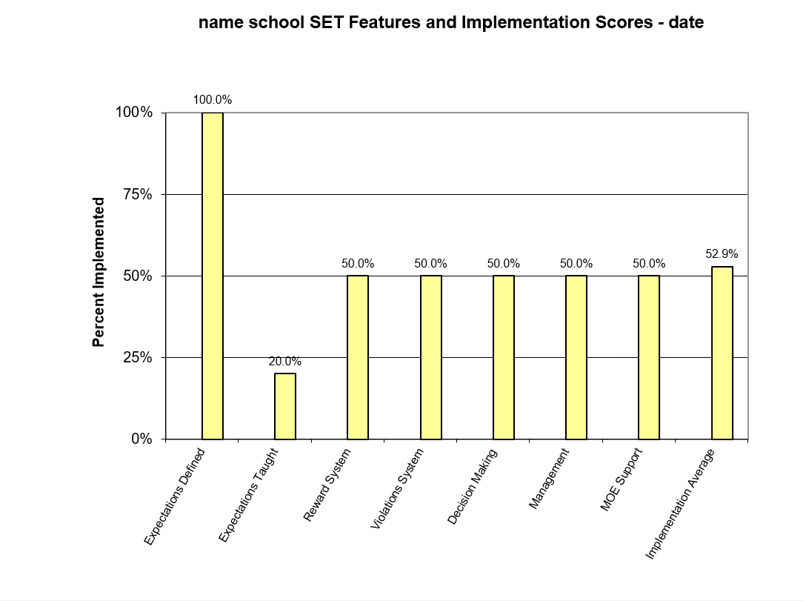

Other 2018 Key Improvement Strategies to Achieve Strategic Vision
Property (summarised from property plan) | Short Report | Finance | Short Report
BOT will continue to work with the ministry team and project manager to complete 5YA projects |  | Work with PTA to explore fundraising opportunities BOT to liaise with PTA in fundraising and funding decisions | 7 March – at a finance meeting attended by Yasmin Renders and Michael Stride we were informed to put a halt on the upgrade of Rooms 5/6 as there was a possibility that another 30K would be removed from our 5YA allocation for waste water and property matters related to the new build. We have already contributed $110k which we approved. At no time was an additional $30K discussed with or approved by the BOT. Neither the Project managers nor the construction company have any knowledge of this. Jasmin Renders was very unclear about this additional cost. We have sent a –please explain email to the MOE.
Personnel | Short Report | Community Engagement | Short Report
Continue to develop the school wide inquiry process for assessing the effectiveness of teaching and learning programmes and continue to implement the attestation and appraisal processes. |  | The BOT has authorised Dairy Flat School to be part of the Orewa COL for professional Learning  We have been assigned two in-school teachers and these will be advertised and appointed in term 1 2017 after our Col achievement goals have been approved  ALLiS  We are part of an Orewa Schools ALLiS project which has provided most (not all) funding for Asian language teaching for our year 5/6 students, in our case Japanese and Mandarin | The two in-school COL staff members have been appointed for another year.  All teachers from the cluster of schools involved attended a conference on 31 Jan which was run by teachers for teachers. Our in-school COL teachers presented a very popular seminar about ‘the junk box’ – an opportunity for students to create in their break times.  We are once again part of the Allis contract which provides fully qualified teachers to teach Mandarin and Japanese to year 5/6 students.

Improvement Plan for a Learning Area-Mathematics
School Strategic Learning Goal:  Continue the development of best practice teaching and learning in Mathematics ensuring appropriate curriculum coverage and individual student learning needs. |  | School Annual Learning Target  That 85% of students achieve at or above the expected level in Mathematics
Baseline data
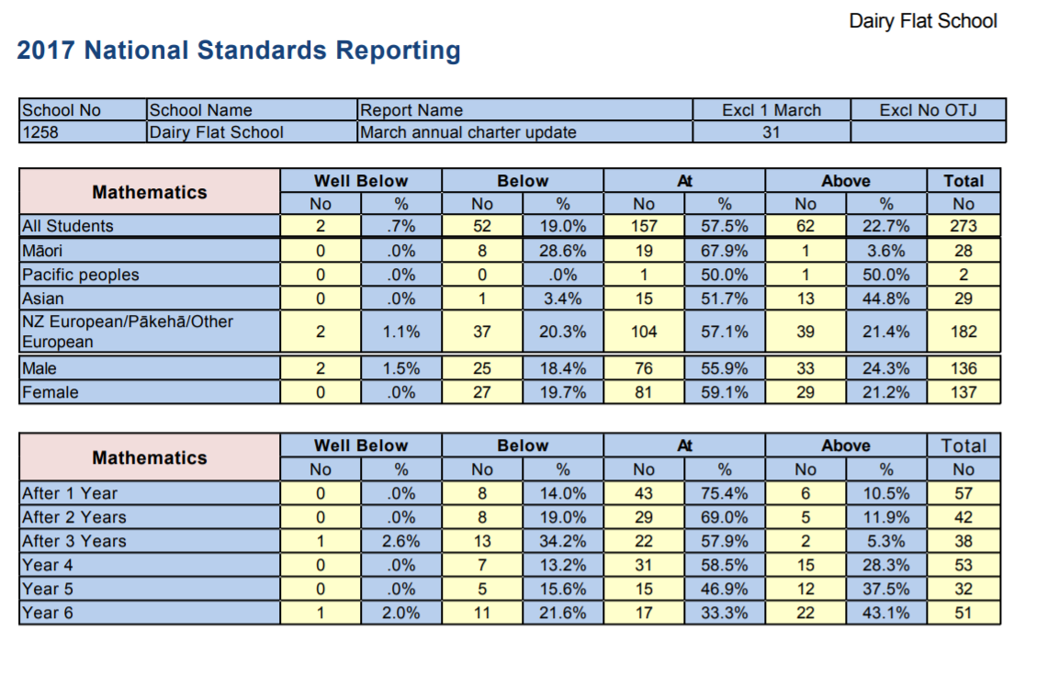

Key Improvement Strategies
This year we are focusing on lifting teacher performance in teaching mathematics by working with a facilitator across the school and with the leadership group.
We have been selected for the second year ALiM programme and wish to spread this across the school. Mathematics will be the main focus of Inquiry for all teachers.
Teachers will reflect on their practice using video and practice analysis conversations with targeted feedback and next steps.

When | What | Who | Indicators of Progress
First 15 weeks beginning Week 6/Term 1 | Regular staff/team/leadership meetings on student writing examples. | Leadership team | Very specific planning docs  Annotated comparison samples  Challenging conversations around progress in leadership/team/staff meetings  Improved progress for target students
Term 1-4 | Include student voice in choice of problem solving and assessment tools | Teachers/students | Evidence of student choice and input into planning
Every 5 weeks from week 6 | Agile planning – every five weeks assess where target students are at, what progress have they made. | All teachers | Completed and detailed planning docs for target students
All year | Regular professional development –teacher only day and twice termly staff meetings as well as leadership meetings | All teachers | Teacher inquiries and reflections will show a focus on continuous improvement.
Monitoring
This will be closely monitored in team meetings, leadership meetings and staff meetings.
Resourcing : PLD – Marie Hirst - $4000 as well as participation in ALiM project.
March Report
We began the year with a half day seminar from Marie Hirst which outlined best practice and provided a number of resources for teachers. There was a focus on teaching knowledge, problem solving and curriculum coverage.
Marie provided updated student learning progressions for teachers to use with students to show where they were achieving at and where to next. We have found progressions have honed teacher knowledge and student understanding of their own learning pathways.
There was a second seminar on 27 Feb. Teachers explored a range of curriculum and assessment resources. A new curriculum implementation plan was delivered for us to use.
The third seminar was held on 27 March and had a focus on collaborative problem solving.

